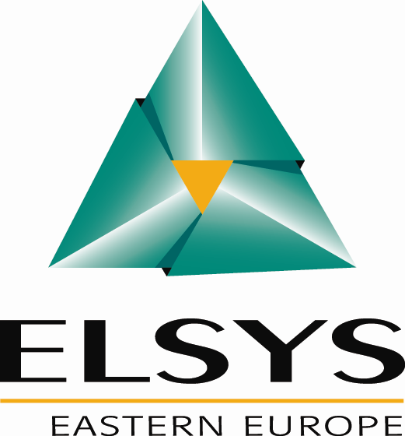

Imagine and Design future electronic systems

ELSYS is electronic design company, with 700 engineers, providing Hardware & Software Expertise and Engineering Services in sectors such as aerospace, nuclear, defense, telecoms, multimedia, industrial, transport and information systems.
As a member of our teams you will have chance to work on the most demanding projects for leading companies in industry like: IBM, INTEL, TI, ST-ERICSSON, ARM, NXP, INFINEON, SCHNEIDER, SAGEM, BULL, NORTEL, THALES, ALCATEL,...
Working on cutting edge Sub-Micronics technologies for next generation ICs, ELSYS is continuously expanding its Digital IC design teams with junior, senior designers and team leaders.

Currently we are looking for:
Digital IC, ASIC and SoC engineers: 3 positions based in Belgrade

The ideal candidate will have following skills and background:
- Highly motivated and dynamic engineer
- Beginner or with professional experience in digital electronics

- Knowledge of VHDL, VERILOG, SYSTEM C
- Knowledge of digital electronics (RTL, bloc and gate levels), ASIC/FPGA
- Knowledge of processor architecture and Systems On Chip
- EDA, Cadence, Synopsys, STA(timing), DFT(design for test), P&R(place & route), Perl

- Knowledge of C/C++ language is a plus.
- Mobility is a plus
- Fluent English is a must

Job description:
You will integrate a team of experts in ASIC/SoC for multi-processors architectures, working on complex modules or applications in cutting edge technologies.

At ELSYS Eastern Europe you will be given full training in Serbia or in France, the opportunity to develop your own ideas, in team, encouraged by a supportive management.

➔ Apply by sending your CV in ENGLISH to: digital.job@elsys-eastern.com
If you have already applied, do not hesitate to mention it while sending your updated resume
www.elsys-eastern.com
ELSYS EE is equal opportunity employer.

